Widget content:

We have all widgets .jsp file place under folder “G4GOrigin/WebRoot/WebContent/widgets”.

All widgets file information placed under widgets folder:

- activePlayers.jsp – As the active player information changes rarely it doesn’t have any AJAX call to refresh regularly. It will be populated only when the game lobby / game details page called.

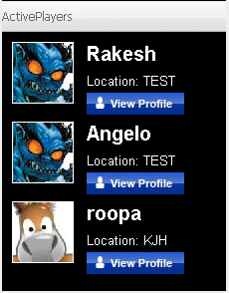

- adBanner.jsp – Banner’s are currently static images and the size of the banner defined on the basis of page on which it is displayed.



- feedback.jsp – Feedback widget are used to send the feedback to the administrator of the site. An admin will get an e-mail when any player sends any feedback to.

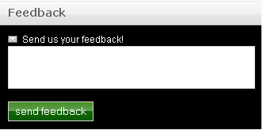

- myFriends.jsp – This widget displays all the friends’ information whose profile is currently viewed by any player. There is no AJAX call to refresh the widget.

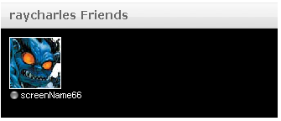

- myLobbies.jsp – This widget list downs all the game lobby name with links that player has currently added to his/her game list. This widget is refreshed whenever users add / remove game from this widget get updated with same effect.

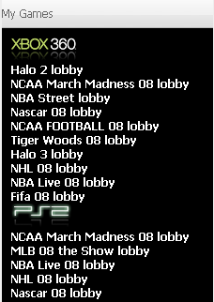

- news.jsp – It currently display this information. Need to integrate with Blog and it gets refreshed on every 60 seconds.

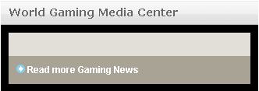

- playNow.jsp – This widget contains latest 3 open matches and tournaments information and it gets refreshed on every 60 seconds.

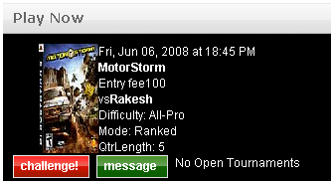
- search.jsp – This widget helps to search People, Games, Tournaments and Open Challenges.



- userTag.jsp – This widget displays the network tag using an outside URL.

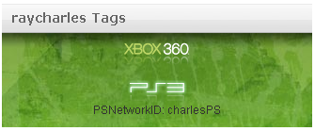

Mails:

We have all mails .jsp file place under folder “G4GOrigin/WebRoot/WebContent/mails”.

- register.jsp – After getting successfully registered with worldgaming player will receive a registration confirmation e-mail.

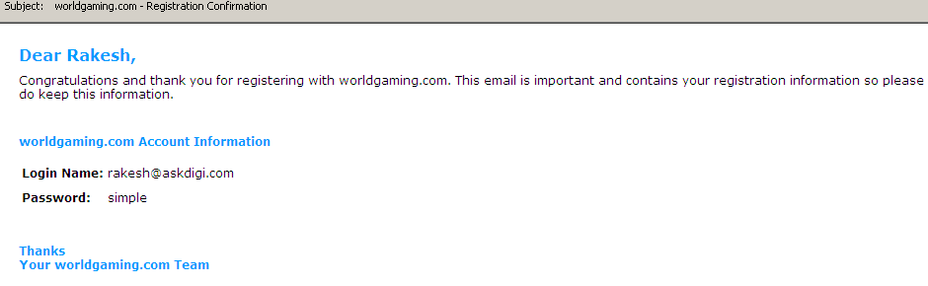

Notification:

There are three kinds of notification in the system. 1) Message 2) Pop-ups and 3) Mails. We have all mails .jsp file place under folder “G4GOrigin/WebRoot/WebContent/wg/notification”

Under that we have 3 other folder for the all kind of notification defined above.

Mails notification (folder named as ‘e-mails’):

Currently no e-mail file is placed under this folder.

Message notification (folder named as ‘messages’):

- cashConfirm.jsp – A message will be sent to player whenever he/she deposit or withdraw an amount from the cashier page.

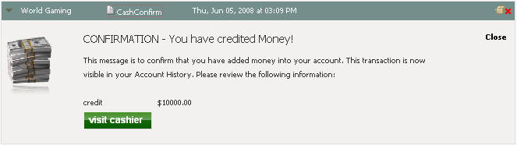

- challengeCanceled.jsp – Whenever a match cancelled by an opponent a player who has generated that match get a cancellation message.

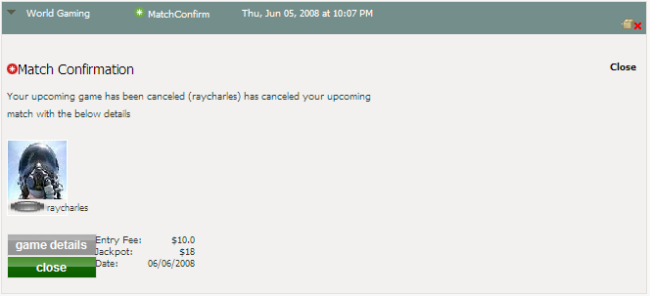

- challengeConfirm.jsp - Whenever a match accepted by an opponent a player who has generated that match get a cancellation message.

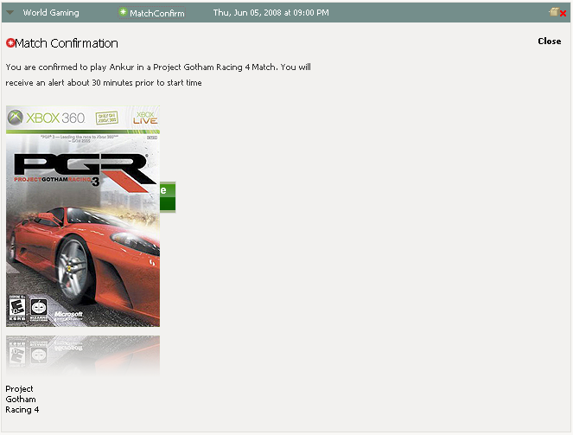

- challengePreview.jsp - Whenever a match has been generated, a message sent to opponent for acceptance or cancellation.

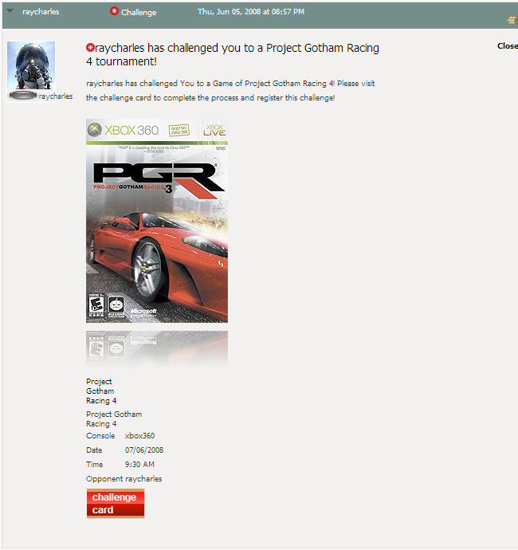

- challengeRejected.jsp - Whenever a match cancelled by an opponent a player who has generated that match get a cancellation message.

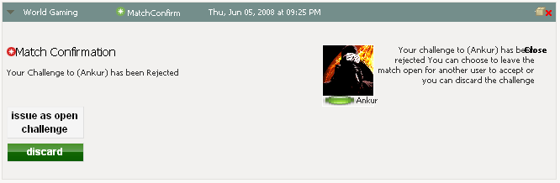

- friendRequest.jsp – Whenever player sends request to other player to be his/her friend a message sent to other player to accept or decline the request.

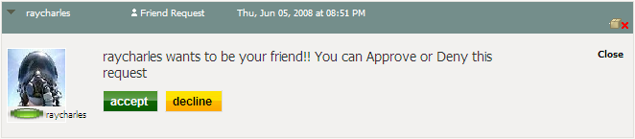

- matchConfirm.jsp – Not implemented.

- matchResult.jsp – After validating the match a match result sent to both the players in that match.

- matchResults.jsp – Not implemented.

- message.jsp – Whenever player compose the message and sent it to other player it will be displayed in his sent item and in new/inbox for recipient player.

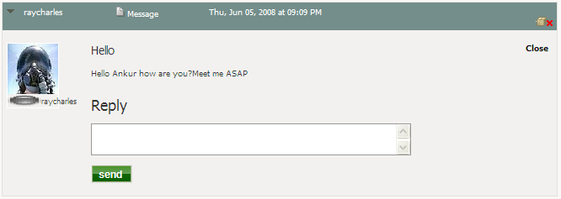

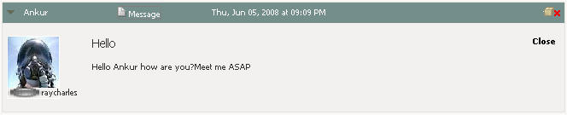

- tournamentJoin.jsp - Whenever player joins a tournament he/she will get a message for match confirm.

Popup notification (folder named as ‘pop-ups’):

- accepted.jsp - Whenever a match accepted by an opponent a player who has generated that match get a cancellation message.

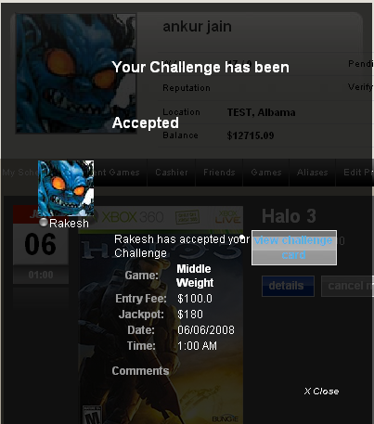

- canceled.jsp - Whenever a match cancelled by an opponent a player who has generated that match get a cancellation message.

- challengePreview.jsp - Whenever a match has been generated, a message sent to opponent for acceptance or cancellation.

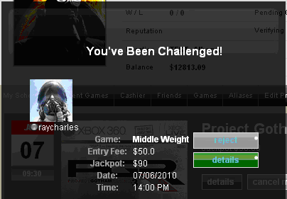

- completed.jsp – Not implemented.

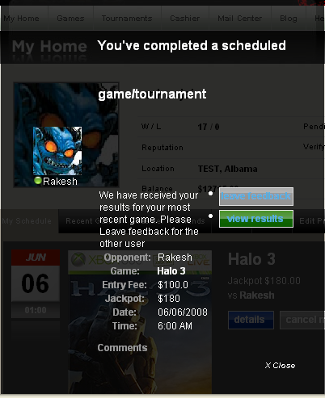

- rejected.jsp - Whenever a match cancelled by an opponent a player who has generated that match get a cancellation message.

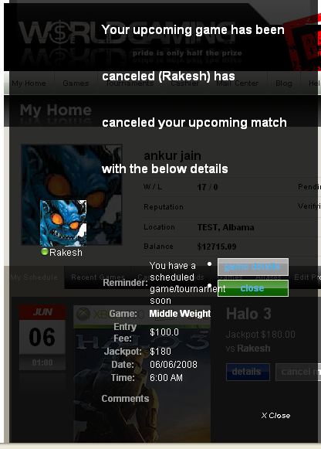

- upcomingMatch.jsp – A popup will be generated before 1 hours of the match schedule, so the player will be notified that he/she has a match which is scheduler after an hour.
